GP Anirudh

180905452

B2

59

5-3-2021

1.) Write a program to find the area of rectangle. Take input from user.

Eg. x= int(input(‘Enter number:’))

w = float(input('Please Enter the Width of a Rectangle: '))

h = float(input('Please Enter the Height of a Rectangle: '))

# calculate the area

Area = w * h

print("\n Area of a Rectangle is: %.2f" %Area)

Output:

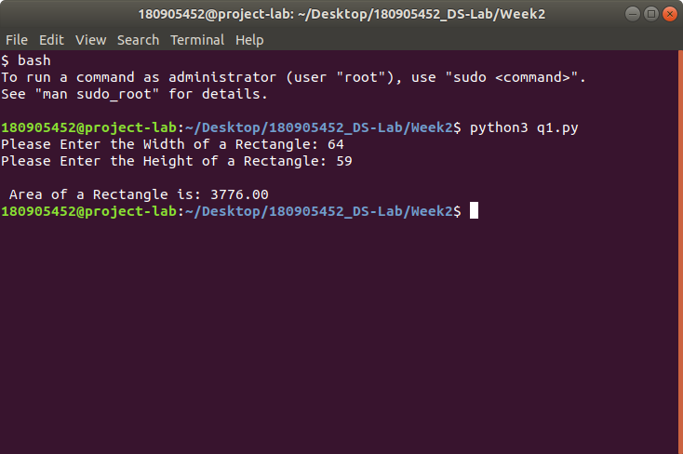

2.) Write a program to swap the values of two variables.

# To take inputs from the user

x = input('Enter value of x: ')

y = input('Enter value of y: ')

x,y = y,x

print('The value of x after swapping: {}'.format(x))

print('The value of y after swapping: {}'.format(y))

Output:

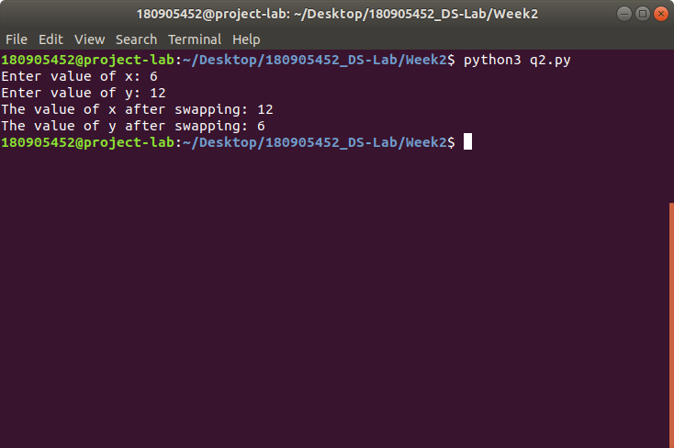

3.) Write a program to find whether a number is even or odd.

# Python program to check if the input number is odd or even.

# A number is even if division by 2 gives a remainder of 0.

# If the remainder is 1, it is an odd number.

num = int(input("Enter a number: "))

if (num % 2) == 0:

print("{0} is Even".format(num))

else:

print("{0} is Odd".format(num))

Output:

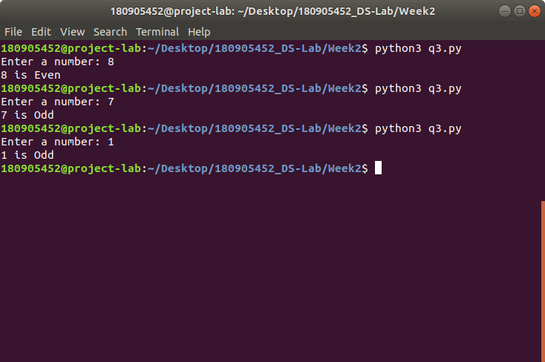

4.) Write a program to check the largest among the given three numbers.

# Python program to find the largest number among the three input numbers

# change the values of num1, num2 and num3 # for a different result

num1 = 10

num2 = 14

num3 = 12

# uncomment following lines to take three numbers from user

#num1 = float(input("Enter first number: "))

#num2 = float(input("Enter second number: "))

#num3 = float(input("Enter third number: "))

if (num1 >= num2) and (num1 >= num3):

largest = num1

elif (num2 >= num1) and (num2 >= num3):

largest = num2

else:

largest = num3

print("The largest number is", largest)

Output:

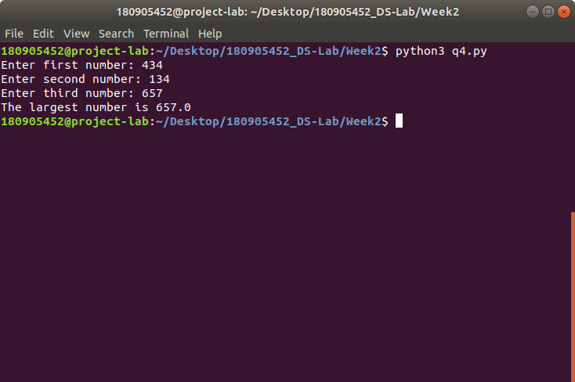

5.) Write a program to demonstrate while loop with else.

# Example to illustrate the use of else statement with the while loop

counter = 0

while counter < 3:

print("Inside loop")

counter = counter + 1

else:

print("Inside else")

Output:

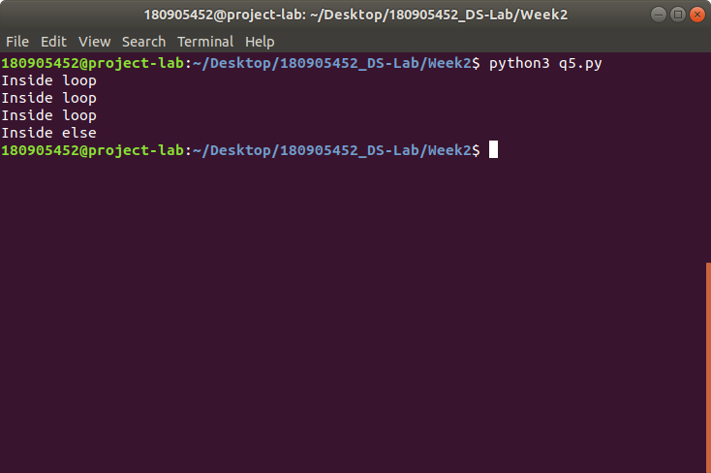

6.) Write a program to print the prime numbers for a user provided range.

# Python program to display all the prime numbers within an interval

lower = int(input("Enter lower range: "))

upper = int(input("Enter upper range: "))

for num in range(lower,upper + 1):

if num > 1:

for i in range(2,num):

if (num % i) == 0:

break

else:

print(num)

Output:

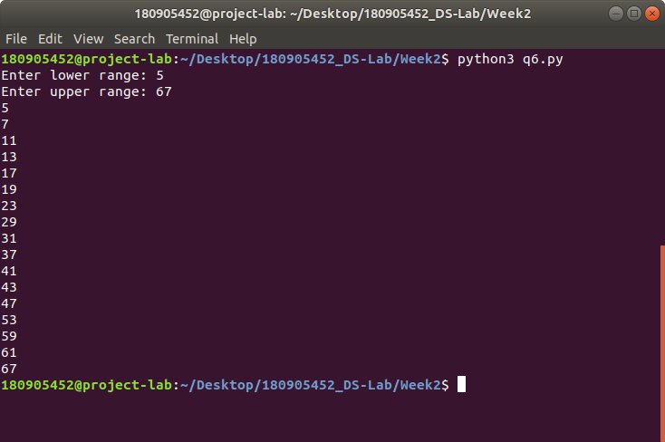

7.) Write a program to demonstrate List functions and operations.

# Python list methods

my_list = [3, 8, 1, 6, 0, 8, 4]

print(my_list.index(8))

print(my_list.count(8))

my_list.sort()

print(my_list)

Output:

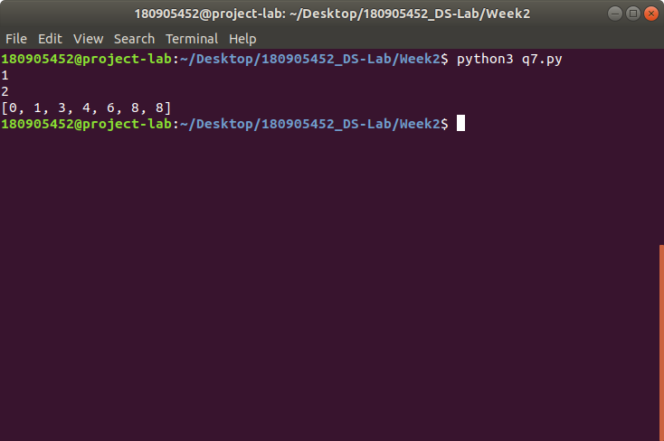

8.) Consider the tuple(1,3,5,7,9,2,4,6,8,10). Write a program to print half its values in one line and the other half in the next line.

data = (1, 3, 5, 7, 9, 2, 4, 6, 8, 10)

for i in range(0, len(data) // 2):

print(data[i], end = ' ')

print()

for i in range(len(data) // 2, len(data)):

print(data[i], end = ' ')

print()

Output:

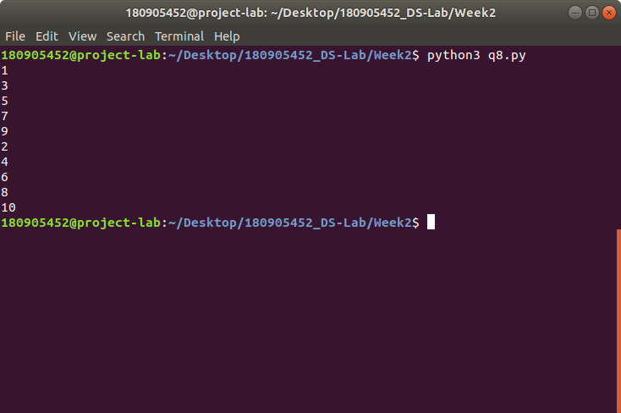

9.) Consider the tuple (12, 7, 38, 56, 78 ). Write a program to print another tuple whose values are even number in the given tuple.

data = (12, 7, 38, 56, 78)

even = tuple(x for x in data if x % 2 == 0)

print(even)

Output:

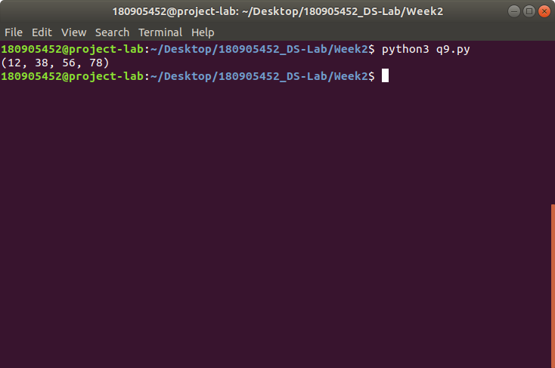

10.) Write a Python program to print negative Numbers in a List using for loop.

Eg. [11, -21, 0, 45, 66, -93].

list = [11, -21, 0, 45, 66, -93]

for x in list:

if x < 0:

print(x)

Output:

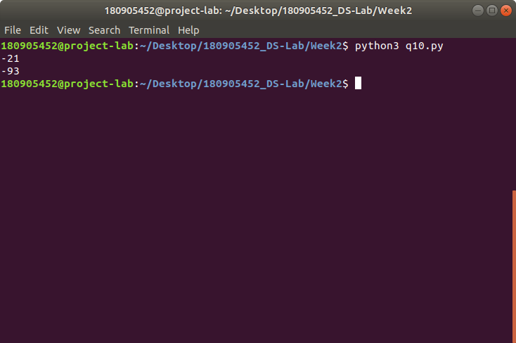

11.) Write a program to print negative Numbers in a List using while loop.

# Python program to print negative Numbers in a List using while loop

# list of numbers

list1 = [-10, 21, -4, -45, -66, 93]

num = 0

# using while loop

while(num < len(list1)):

# checking condition

if list1[num] < 0:

print(list1[num], end = " ")

# increment num

num += 1

Output:

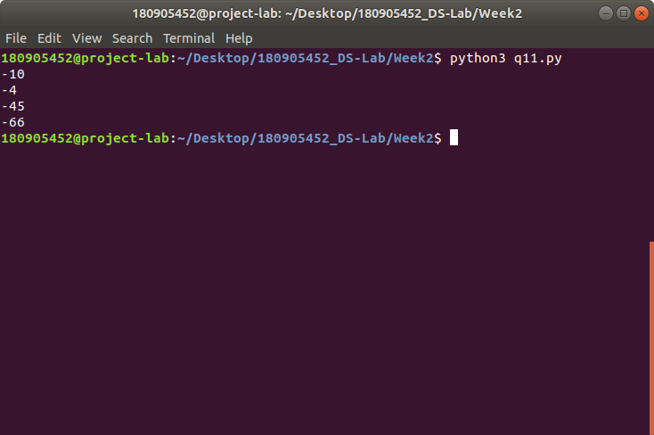

12.) Write a Python program to count positive and negative numbers in a List.

# Python program to count positive and negative numbers in a List

# list of numbers

list1 = [10, -21, 4, -45, 66, -93, 1]

pos_count, neg_count = 0, 0

# iterating each number in list for num in list1:

# checking condition

if num >= 0:

pos_count += 1

else:

neg_count += 1

print("Positive numbers in the list: ", pos_count)

print("Negative numbers in the list: ", neg_count)

Output:

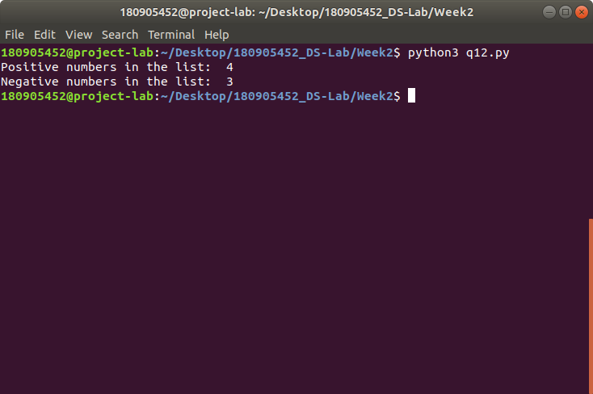

13.) Write a Python program to remove all even elements from a list .

list = [11, -21, 0, 45, 66, -93]

print('Original list: ', list)

for x in list:

if x % 2 == 0:

list.remove(x)

print('After removing even numbers:', list)

Output:

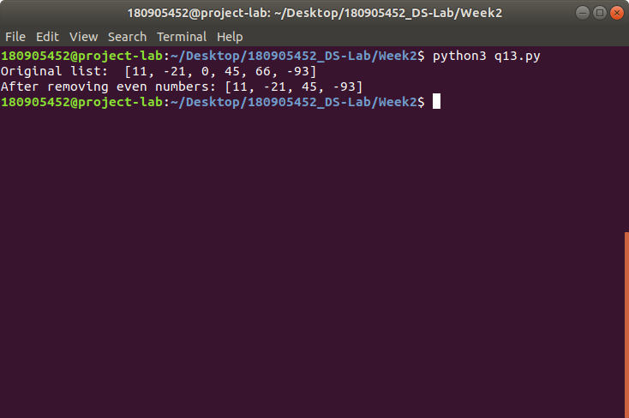

14.) Define a dictionary containing Students data {Name, Height, Qualification}.

1. Convert the dictionary into DataFrame
2. Declare a list that is to be converted into a new column (Address}
3. Using 'Address' as the column name and equate it to the list and display the result.

import pandas as pd

data = {'Name': ['GP Anirudh', 'Tom', 'Harry'],

'Height': [181, 180, 179],

'Qualification': ['BTech', 'MS', 'PhD']}

df = pd.DataFrame.from_dict(data)

addr_list = ['Hyderabad', 'Lucknow', 'Kolkata']

df['Address'] = addr_list

print(df.head())

Output:

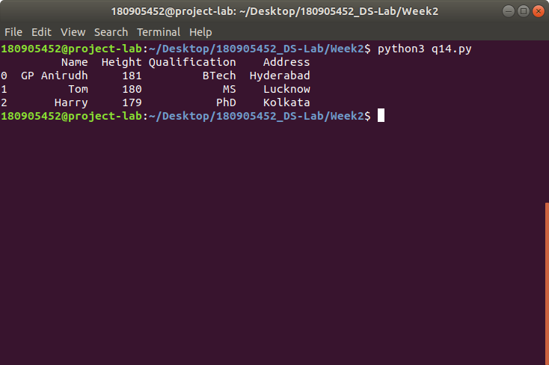

15.) Define a dictionary containing Students data {Name, Height, Qualification}.

a. Convert the dictionary into DataFrame

b. Use DataFrame.insert() to add a column and display the result.

import pandas as pd

data = {'Name': ['GP Anirudh', 'Tom', 'Harry'],

'Height': [181, 180, 179],

'Qualification': ['BTech', 'MS', 'PhD']}

df = pd.DataFrame.from_dict(data) cols = [18, 19,20]

df.insert(3, 'Age', cols)

print(df.head())

Output:

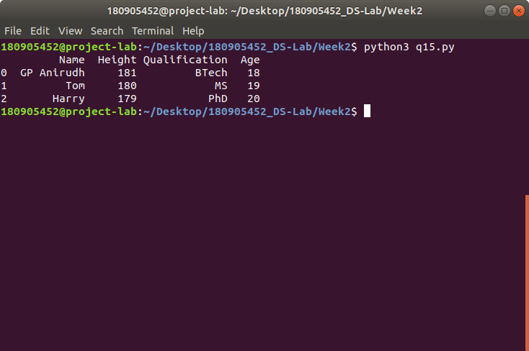

16.)

import pandas as pd

import numpy as np

import openpyxl

import matplotlib.pyplot as plt

df = pd.read_excel('German Credit.xlsx',sheet_name='Sheet1',engine='openpyxl')

print(df.head())

print(df.columns)

plt.scatter(df['Creditability'],df['CreditAmount'])

plt.xlabel('Creditability')

plt.ylabel('CreditAmount')

df['CreditAmount'].hist()

plt.boxplot(df,notch=True)

f = df['Creditability'].value_counts()

f.plot(kind='bar')

f.plot(kind='pie')

f = pd.crosstab(df['Creditability'],df['DurationOfCreditInMonths'])

f.plot(kind='bar')

plt.show()

Output:

